# Login/ Register

* [Home](https://newroots.org/)
* Login/ Register

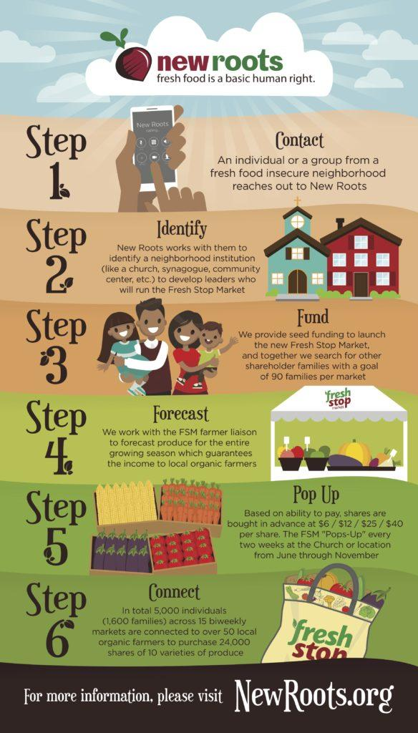

#### **Login**

[bbp-login]

#### **Forgot Password?**

[bbp-lost-pass]

#### **Register**

[bbp-register]

